

Press Release:  For Immediate Release | Company Contact:  Ashley Sullins  asullins@rapa.com  334.321.0875 | Business Location:  Auburn, Alabama  2450 Paul Parks Lane  Auburn, AL 36832
Topic:  FCA Quality Award Recipient | Date:  September 25th, 2019 | Scope:  Manufacturing

On Wednesday, September 25th, 2019, Fiat Chrysler Automobiles (FCA) traveled to Auburn, AL to award RAPA LP with its distinguished “2018 Outstanding Quality Supplier” award. This is the third nomination, but the first year that the specialty valve manufacturer received the award. Less than 50 manufacturing locations worldwide will receive this honor. RAPA LP is a member of the RAPA Group located in Selb, Germany located two hours North of Munich, Germany.

RAPA LP won this award for their outstanding quality, delivery and service provided to FCA and their powertrain plants located in Kokomo, IN during 2018. RAPA LP has been a supplier to FCA Kokomo plants for the past four years and will continue doing so for the foreseeable future. RAPA LP has 115 employees and a current sales volume of some 50 million dollars.

Mr. Vito LoMedico from FCA handed the award to Mr. Sly Long of RAPA LP during a short ceremony on the morning of the 25th. Mr. Long is a shift leader and has been with RAPA LP since it began production in 2014. “It is a real honor to accept this award on behalf of our entire team, especially our hourly associates who support the culture that allows for these types of things to happen” Mr. Long was quoted after accepting the award.

“Positive recognition from your customer is always an objective, and it has been since the Board of Directors choose to open a plant here in Auburn” said Mr. Kelly Nelson, President and CEO of RAPA LP. “Dr. Roman Pausch and his father Horst felt something special about the South and the sense of community, specifically the Auburn area, and I think they were accurate in that feeling.” RAPA Group designs and manufactures a wide variety of Automotive, Industrial and Medical valves and pumps. RAPA LP in Auburn is currently dedicated to the NAFTA Automotive market producing powertrain and suspension products. Their R&D department is currently working on autonomous vehicle applications as well.

While RAPA has been a well-known and trusted supplier in European for many years across many OEM platforms, it was not as well known in the US. “Obtaining a higher level of name recognition within the US market has been one of the first challenges to overcome” said Nelson. “This award certainly helps us improve towards that goal”

RAPA GmbH will celebrate its 100th year of business in 2020. “With electrification and autonomous driving, the face of our business is changing rapidly and we stand ready for ‘what’s next’” Nelson added.

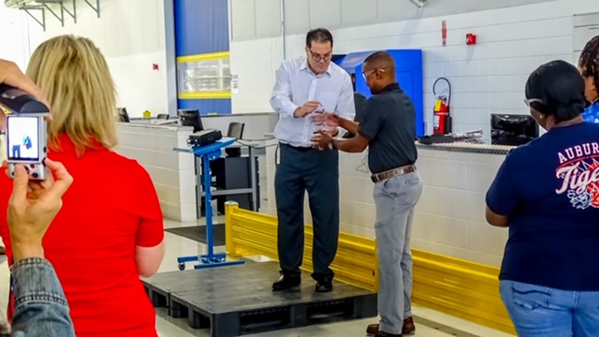
Mr. Vito LoMedico of FCA presents award to Sly Long, Shift Leader of RAPA LP.

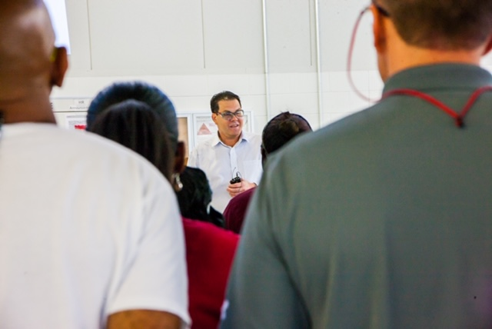
Mr. Vito LoMedico explains the significance of the award to RAPA LP associates

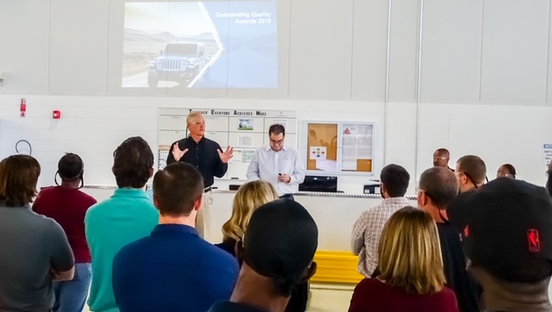
Mr. Kelly Nelson and Mr. Vito LoMedico address the associates of RAPA LP during the award presentation.

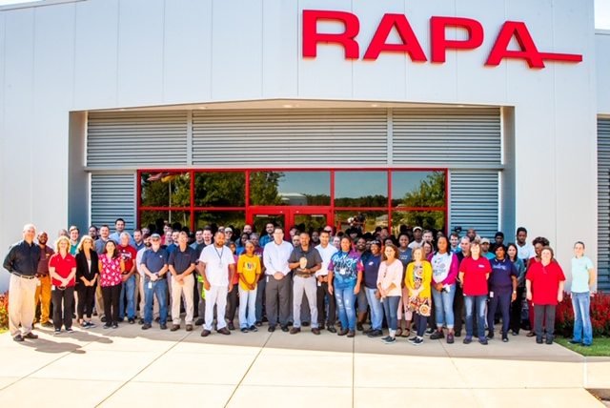
RAPA LP Associates along with FCA representatives pose for a picture with the award outside of the facility located in Auburn’s Industrial Park West.

